Company name and/or logo: Report submitted on:
31 / 07 / 2026
/ year
dsm-firmenich
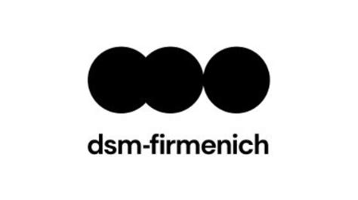

Type of business/sector  (E.g. retail, dairy) | Sustainability dimension  (E.g. environmental, social) | Code aspirational objective  (1-7) | Individual commitments with baseline | Progress on KPIs and goals (qualitative and/or quantitative) | Additional information and/or comments (optional)  (E.g. partnerships, geographical coverage, ideas on how to improve)
Consumer Ingredients | Environmental Sustainability | 3 - Climate neutral food chain in Europe by 2050 | Reach net zero GHGe across our operations and value chain by 2050 | Our intermediate targets for our net-zero-by-2045 commitment are our Science Based Targets (SBT).  Our SBT are an absolute reduction of GHG emissions from our operations (scope 1 + 2) by 42% and a value chain (scope 3) intensity reduction of 25%, both by 2030 versus our 2021 baseline. | Our climate mitigation activities include:  1] Reduction of direct emissions in our operations (Scope 1 and 2) through operational efficiency and our renewable electricity transition strategy.  2] Reduction of indirect emissions in our value chain by driving Scope 3 improvements through engaging and collaboration with our suppliers.  3] Collaborating with our customers to avoid emissions in their own operations through the products and services we offer.  To deliver our net-zero target. The percentage of purchased electricity from renewable sources increased globally to 100% in 2025.
   | Target Level | 2025 | 2024
  Scope 1 + 2 | 42% | 31% | 27%
  Scope 3 | 25% | 23% | 20%

